**Bus Reservation**

This application is developed for book bus and volvo tickets in the easiest & fastest way. The application allows you to search and book bus tickets. User can choose from seater, sleeper, semi-sleeper, A/C, non A/C buses. User can phone booking.

**Fetures of application**.

* Find buses & route information: Use the app to check availability and price of buses & operators in India.
* Select Boarding points: Choose user boarding point on a map and get directions.
* One touch Cancellations: Cancel tickets using the application with a single tap.
* Save ticket details
* Ratings: Get ratings of buses based on fellow customers feedback for each operator.

**Screen shot.**

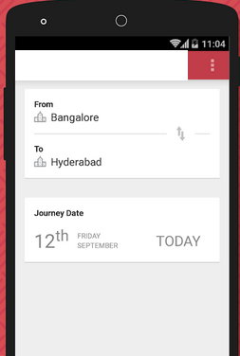

* User can easily select own rout using this module.

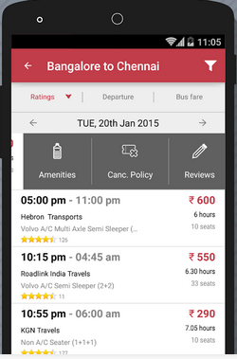

* User can choose different types of buses and volvo.

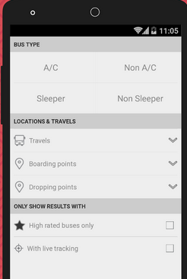

* User can choose bus different category wise.

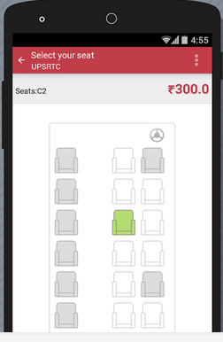

* User can also select own setting arrangement.

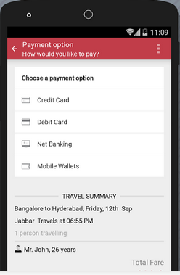

* User can payment different different ways.